**INTELLIGENT TRANSPORT SYSTEM USING VANET FOR EMERGENCY MEDICAL SERVICES**

A PROJECT REPORT

*Submitted by*

SRIVATSAN NARASIMAHN

*In fulfillment for the FIRST PHASE OF FINAL YEAR PROJECT*



MADRAS INSTITUTE OF TECHNOLOGY

ANNA UNIVERSITY: CHENNAI 600 044

NOVEMBER 2017

|  |  |  |
| --- | --- | --- |
| **TABLE AND CONTENTS** | | |
| **CHAPTER NO.** | **TITLE** | **PAGE NO.** |
|  | ABSTRACT | i |
|  | LIST OF FIGURES | ii |
| 1 | INTRODUCTION | 1 |
|  | * 1. Overview of Emergency Medical Services | 1 |
|  | * + 1. EMS Systems | 2 |
|  | 1.2 EMS system based on VANET | 4 |
|  | 1.3 Multiple casting protocol | 8 |
|  | 1.4 Geographical based routing | 10 |
|  |  |  |
| 2 | LITERATURE SURVEY | 12 |
|  | 2.1 Time-critical vehicle routing | 12 |
|  | 2.2 Traffic Control System | 13 |
|  | 2.3 Advanced Realtime monitoring | 13 |
|  | 2.4 Enhancing Emergency care using VANET | 14 |
|  | 2.5 VANET services in Emergency situations | 15 |
|  | 2.6 Traffic flow control for Megapolis cities | 15 |
| 3 | PROPOSED SYSTEM | 16 |
|  | 3.1 Introduction | 16 |
|  | 3.2 Analysis of physical parameters using real traffic  data | 16 |
|  | 3.3 Vehicular Trajectories | 17 |
|  | 3.4 Architecture | 18 |
|  |  |  |
| 4 | IMPLEMENTATION DISCUSSION | 20 |
|  | 4.1 Algorithm | 20 |
|  | 4.2 Simulation of Vehicles and Traffic | 21 |
|  | 4.3 Dissemination of Packets | 22 |
|  | 4.4 Priority to Emergency Vehicles | 23 |
| 5 | RESULT AND DISCUSSION | 26 |
| 6 | CONCLUSION AND FUTURE WORK | 27 |
|  | 6.1 CONCLUSION | 27 |
|  | 6.2 FUTURE WORK | 27 |
|  |  |  |
| 7 | REFERENCES | 28 |

**ABSTRACT**

The main objective is to provide a proper framework for Traffic monitoring system and to manage traffic by rerouting vehicles. In the existing approach the traffic constraint is not considered for the propagation of the emergency services. Congestion is usually looked at as the number of vehicles that pass through a point in a window of time, or a flow. In our proposed system we design an module to monitor and control traffic using Vehicle ad-hoc networks (VANETs). Using VANET the cars in a network can communicate with each other and thus by dissemination of data between the vehicles, the efficiency of the transport system can be increased. So when an emergency vehicle arrives the nearby vehicles are notified and the priority is given to the emergency vehicle such that the other cars are rerouted or made to change lanes to give way to the former emergency vehicle. So the above mentioned VANET based ad-hoc network is used in Emeregency medical services.

**LIST OF FIGURES**

|  |  |  |
| --- | --- | --- |
| **FIGURE NO.** | **TITLE** | **PAGE NO.** |
| 1.1 | Vehicular ad-hoc network | 7 |
| 1.2 | Collision warning – VANET | 8 |
| 1.3 | Vehicle to X communication | 11 |
| 3.1 | Coverage graph of vehicle | 18 |
| 3.2 | Architecture of Ad-hoc network | 18 |
| 4.1 | Real world map simulation | 22 |
| 4.2 | Traffic signals in real world map | 22 |
| 4.3 | Packet Tracing between vehicles | 23 |
| 4.4 | Simulation of the Traffic signals | 25 |
| 4.5 | Priority for Emergency vehicles | 25 |

**CHAPTER 1**

**INTRODUCTION**

**1.1 EMERGENCY MEDICAL SERVICES-AN OVERVIEW**

**Emergency medical services**, also known as **ambulance services** or **hospital services** are a type of emergency service dedicated to providing out-of-hospital acute medical care, transport to definitive care, and other medical transport to patients with illnesses and injuries which prevent the patient from transporting themselves.Emergency medical services may also be globally known as a medical services, ambulance service, a first aid service, fast service, emergency service, safe guarding service, ambulance corps, or life squad.

The goal of most emergency medical services is to either provide treatment to those in need of urgent medical care, with the goal of satisfactorily treating the presenting conditions, or arranging for periodical removal  to the next point of definitive care of the patient. This is more or less relative to an emergency network in the hospital. During transport emergency medical service evolved to reflect a change from a simple system of emergency vehicle providing only transportation network, to the system in which primary medical care is provided on spot.

The emergency medical service also encompasses the role of moving patients from one medical facility to an alternative one; usually to facilitate the provision of a higher level or more specific department of care and also to transfer from a specialized facility of the centre to a hospital when they no longer require the services of that specialized hospital, such as following successful due to a heart attack. In such services, the EMS is not summoned by members of the public but by clinical professionals (e.g. physicians or nurses) in the referring facility. Specialized hospitals that provide higher levels of care may include services such as neonanal intensive care (NICU), pediatric intensive care (PICU), state regional burn centres, specialized care for spinal injury and/or neurosurgery regional stroke centers, specialized cardiac care, and specialized/regional trauma care.

### **1.1.1 Emergency medical services system**

### **Emergency vehicle notification systems**

The inside-vehicle electronic message call is, generated either manually by the vehicular drivers or automatically via activation of in-vehicle detectors after the emergency. When activated, the in-vehicle electronic message call device will establish an emergency call carrying both voice and data directly to the nearest emergency point (normally the nearest E1-1-2 public-safety answering point, PSAP). At the same time, a minimum set of data about the incident and other information will be, sent to the electronic message call operator receiving the voice based call.

The minimum datasets contains the information about the incident, including time, precise location, the direction the vehicle was traveling, and vehicle identification. The pan-European electronic message call aims to be operative for all new type-approved vehicles as a standard option. Depending on the manufacturer of the electronic message call system, it could be mobile phone based, an integrated electronic message call device, or a functionality based on the broader system like navigation, or like the tolling device. Electronic message call is expected to be offered, at earliest, by the end pending standardization by the European Telecommunications Standards Institute and commitment from large EU member states such as France and the United Kingdom.

The EC funded project Safe trip is developing an open ITS system that will improve road safety and provide a resilient communication through, the use of S-band satellite communication. Such platform will allow for greater coverage of the Emergency Call Service within the EU.

### **Automatic road enforcement**

A traffic enforcement camera system, consisting of a camera and a vehicle-monitoring device, is used to detect and identify vehicles disobeying a speed limit or some other road legal requirement and automatically ticket offenders based on the license plate number. Traffic tickets are, sent by mail. Applications include:

* Fast movement cameras that clearly identify the vehicles which are traveling over the speed limit of the region. Many such devices use radar in order  to detect the vehicle's speed detected in each lane of the monitored road.
* Red signal detecting cameras that detect the vehicles that overcome than a stop line or designated place while a red traffic signal light is blinking.
* Bus lane cameras that identify vehicles traveling in lanes reserved for buses. In some jurisdictions, bus lanes can also be used by taxis or vehicles engaged in car pooling.
* Railway crossing is easily monitored by means of tracking the vehicles illegally crossing the level by level crossing cameras.
* Double white line cameras that identify vehicles crossing these lines.
* High-occupancy vehicle lane cameras that identify vehicles violating HOV requirements.

### **Variable speed limits**

Recently some jurisdictions have begun experimenting with variable speed limits that change with road congestion and other factors. Typically, such speed limits only change to decline during poor conditions, rather than being, improved in good ones. One example is on Britain's M25 motorway, which circumnavigates London. On the most heavily travelled for 14-mile (23 km) section (junction 10 to 16) of the M25 variable speed limits combined with automated enforcement have been in force since 1995. Initial results indicated savings in journey times, smoother-flowing traffic, and a fall in the number of accidents, so the implementation was, made permanent in 1997. Further trials on the M25 have been, thus far proven inconclusive.

### **Dynamic traffic updation sequence**

A 2008 paper was, written about using RFID for dynamic traffic light sequences. It circumvents or avoids problems that usually arise with systems that use image processing and beam interruption techniques. RFID technology with appropriate algorithm and database were, applied to a multi-vehicle, multi-lane and multi-road junction area to provide an efficient time management scheme. A dynamic time schedule was, worked out for the passage of each column. The simulation showed the dynamic sequence algorithm could adjust itself even with the presence of some extreme cases. The paper said the system could emulate the judgment of a traffic police officer on duty, by considering the number of vehicles in each column and the routing proprieties.

**1.2 Emergency vehicle system based on** **VANET**

**Vehicular ad hoc networks** (**VANETs**) are created by implementing the principles of mobile ad-hoc related network – the spontaneous creation of a wireless connectionless network for data transfer – to the domain of the vehicles. VANETs were first mentioned and introduced  in 2001 under "car-to-car ad hoc mobile communication and networking" applications, where networks can be formed and information can be relayed among cars. It was shown that vehicle-to-vehicle and vehicle-to-roadside communications architectures will co-exist in VANETs to provide road safety, navigation, and other roadside services. VANETs are a key part of the intelligent transportation systems(ITS) framework. Sometimes, VANETs are referred as Intelligent Transportation Networks. The term VANET became the mostly used synonymous word with the more generic used term of the **inter-vehicular communication** (**IVC**), although the focus mainly remains over the aspect of the networking model, much lesser over the use of infrastructure based on Road Side Units (RSUs) or cellular mobile based networks.

VANETs support a wide range of applications – from simple one hop information dissemination of, e.g., cooperative awareness messages (CAMs) to multi-hop dissemination of messages over vast distances. Rather than moving at random, vehicles tend to move in an organized fashion. The interactions with roadside equipment can likewise be characterized fairly accurately. And finally, most vehicles are restricted in their range of motion, for example by being constrained to follow a paved highway. Vehicles are likely to move in structured way. The connection with wayside equipment can similarly be indicated absolutely accurately. In the end, mostly automobiles are limited in their motion range, such as being controlled to pursue a paved way. VANET suggests unlimited advantage to companies of any size. Vehicles access of fast speed internet which will change the automobiles’ on-board system from an effective widget to necessary productivity equipment, making nearly any internet technology accessible in the car. Thus this network does pretend specific security concerns as one problem is no one can type an email during driving safely. This is not a potential limit of VANET as productivity equipment. It permits the time which has wasted for something in waiting called “dead time”, has turned into the time which is used to achieve tasks called “live time”.

If a traveler downloads his email, he can transform jam traffic into a productive task and read on-board system and read it himself if traffic stuck. One can browse the internet when someone is waiting in car for a relative or friend. If GPS system is integrated it can give us a benefit about traffic related to reports to support the fastest way to work. Finally, it would permit for free, like Skype or Google Talk services within workers, reducing telecommunications charges.

Example applications of VANETs are:

* **Electronic brake lights**, which allow a driver (or an autonomous car or truck) to react to vehicles braking even though they might be obscured (e.g., by other vehicles). Safety applications in vehicular networks have been popular research topics in recent years, such as forward collision warning, emergency braking warning and intersection collision warning systems. The basic safety message broadcast from each car transmits the position, car speed and car heading information. Neighbouring cars receiving this information can decide if there is any danger within the next second
* [**Platooning**](https://en.wikipedia.org/wiki/Platoon_(automobile)), which allows vehicles to closely (down to a few inches) follow a leading vehicle by wirelessly receiving acceleration and steering information, thus forming electronically coupled "road trains". This will help in efficient usage of road space thus reducing the traffic accumulation in roads and efficient transport without any accidents.
* **Traffic information systems**, which use VANET communication to provide up-to-the minute obstacle reports to a vehicle's satellite navigation system. This could improve the efficiency of Intelligent transportation system because all the parameters are monitored so as to avoid any collision or accident.
* **Road Transportation Emergency Services** - where VANET communications, VANET networks, and road safety warning and status information dissemination are used to reduce delays and speed up emergency rescue operations to save the lives of those injured. A VANET system may use the dissemination of messages between different vehicles and intimate the nearby vehicles that an emergency vehicle is approaching them and warn them to give way to the vehicle.
* **On-The-Road Services** - It is also envisioned that future transportation highway would be one that is "information-driven" and "wirelessly-enabled". When one drives on the road, VANETs can help the driver to discover services (shops, gas stations, etc) on that street, and even be notified of any sale going on at that moment. Drivers can also book a cinema ticket while driving their way to the cinemas. This could allow the user to have a complete view of his/her surroundings to know about the nearby areas.

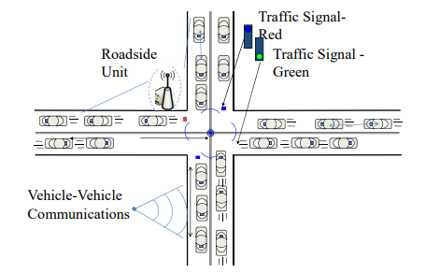

**Figure 1.1 Vehicular ad-hoc network**

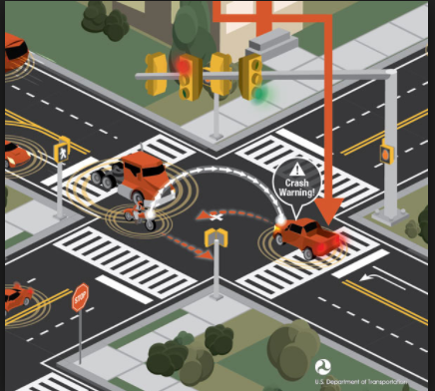

**Figure 1.2 Collision warning - VANET**

**1.3 Multiple casting protocol**

Multicast IP Routing protocols are used to distribute data (for example, audio/video streaming broadcasts) to multiple recipients. Using multicast, a source can send a single copy of data to a single multicast address, which is then distributed to an entire group of recipients.

A multicast group identifies a set of recipients that are interested in a particular data stream, and is, represented by an IP address from a well-defined range. Data sent to this IP address is, forwarded to all members of the multicast group.

Routers between the source and recipients duplicate data packets and forward multiple copies wherever the path to recipients diverges. Group membership information is, used to calculate the best routers at which to duplicate the packets in the data stream to optimize the use of the network.

A source host sends data to a multicast group by simply setting the destination IP address of the datagram to be the multicast group address. Any host can become a source and send data to a multicast group. Sources do not need to register in any way before they can begin sending data to a group, and do not need to be members of the group themselves.Group communication may either be *application layer multicast* or *network assisted multicast*, where the latter makes it possible for the source to efficiently send to the group in a single transmission. Copies are, automatically created in other network elements, such as routers, switches and cellular network base stations, but only to network segments that currently contain members of the group. Network assisted multicast may be implemented at the data link layer using one-to-many addressing and switching such as Ethernet multicast addressing, Asynchronous Transfer Mode (ATM), point-to-multipoint virtual circuits (P2MP) or Infiniband multicast. Network assisted multicast may also be implemented at the Internet layer using IP multicast. In IP multicast the implementation of the multicast concept occurs at the IP routing level, where routers create optimal distribution paths for datagrams sent to a multicast destination address.

There are many different multicast protocols and modes of operation, each optimized, for a particular scenario. Many of these are still at an early stage of standardization. However, they all operate in the same general way, as follows.

* A **Multicast Group Membership Discovery** protocol is, used by receiving hosts to advertise their group membership to a local multicast router, enabling them to join and leave multicast groups. The main Multicast Group Membership Discovery protocols are Internet Group Management Protocol (IGMP) for IPv4 and Multicast Listener Discovery (MLD) for IPv6.
* A **Multicast Routing Protocol** is, used to communicate between multicast routers and enables them to calculate the multicast distribution tree of receiving hosts. Protocol Independent Multicast (PIM) is the most important Multicast Routing Protocol.

The multicast distribution tree of receiving hosts holds the route to every recipient that has joined the multicast group, and is optimized so that

* multicast traffic does not reach networks that do not have any such recipients (unless the network is a transit network on the way to other recipients)
* Duplicate copies of packets are, kept to a minimum.

**1.4 Geographical based casting**

**Geocast** refers to the delivery of information to a group of destinations in a network identified by their geographical locations. It is a specialized form of multicast addressing used by some routing protocols for mobile ad hoc networks. Group members are within a specified geographical region. Whenever a node in the geo-cast region receives a geo-cast packet, it floods the geo-cast packet to all its neighbours.

A geo-cast protocol works if at least one node in the geo-cast region receives the geo-cast packet. Protocols use a jitter technique in order to avoid two packets colliding with each other by a broadcast. Existing geo-cast protocols divided into two categories: data-transmission oriented protocols routing creation, oriented protocols The difference is how they transmit information from a source to one or more nodes in the geo-cast region.

Extends the LAR unicast routing algorithm for geo-casting. Utilize location information to improve the performance of a unicast routing protocol The goal is to decrease delivery overhead of geo-cast packets by reducing the forwarding space for geo-cast packets, while maintaining accuracy of data delivery The algorithm is based upon a flooding approach while a node determines whether to forward a geo-cast packet further via one of two schemes.

A geographic destination address is expressed in three ways: point, circle (with centre point and radius), and polygon (a list of points, e.g., P(1), P(2), …, P(n–1), P(n), P(1)). A geographic router (Geo Router) calculates its service area (geographic area it serves) as the union of the geographic areas covered by the networks attached to it. This service area is, approximated by a single closed polygon. Geo Routers exchange service area polygons to build routing tables. The routers are, organized in a hierarchy.

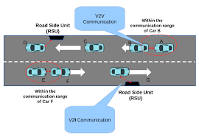

**Figure 1.3 Vehicle to X communication**

**CHAPTER 2**

**LITERATURE SURVEY**

**2.1 Time-critical vehicle routing problem**

Traditionally, vehicle routing problems are defined on a network in which the end-user locations are given. Typically, these arcs somehow represent the distances or expected travel time derived from the underlying road network. The quality of the solutions obtained from the vehicle routing problem depends on the quality of the road network representation. This paper [1] explicitly considers path selection in the road network as an integrated decision in the time-dependent vehicle routing problem, denoted as path flexibility (PF). This means that any path between two customer nodes has multiple corresponding paths in the road network. Hence, the decisions to make are involving not only the routing decision but also the path selection decision depending upon the departure time at the customers and the congestion levels in the relevant road network. The actual routing problem depends upon the time factor with path flexibility. We formulate the TDVRP–PF models under deterministic and stochastic traffic conditions. We derive important insights, relationships, and solution structures. Based on a representative test bed of instances (inspired on the road network of Beijing), significant savings are obtained in terms of cost and fuel consumption, by explicitly considering path flexibility. Having both path flexibility and time- dependent travel time seems to be a good representation of a wide range of stochasticity and dynamics in the travel time, and path flexibility serves as a natural recourse under stochastic conditions. Exploiting this observation, we employ a Route-Path approximation method generating near-optimal solutions for the TDVRP–PF under stochastic traffic conditions.

**2.2 Traffic Control systems**

Traffic is a major concern for most of the metropolitan cities of the world. Efficient traffic management can have a major impact on the country's economy. This paper [2] proposes a new digital-logic based system which is more efficient than currently used traffic control systems. The Intelligent Traffic Control System (ITSC) is based on a simple principle; the principle being that "a car can only move ahead if there is space for it" and "the signal remains green until the present cars have passed". By placing sensors at every entry and exit of a junction and monitoring the number of cars present at the junction, it is

possible to make traffic very efficient, which is a good application of Digital Signal Processing. However, absolute advantage of such a system will only be felt if every junction in a city is controlled by this system.

**2.3 Advanced Real-Time Traffic Monitoring System**

The number of vehicles on roads keeps increasing continuously, making the management of traffic flow, especially in big cities more and more challenging. One of the key enablers for having smooth traffic flows and better mobility is to rely on real-time traffic monitoring systems. These systems allow road operators to implement intelligent traffic management strategies such as the dynamic adjustment of timing and phasing of traffic lights and the adaptive road congestion charging. Moreover , better informed travelers will plan smartly their journeys and hence potentially contribute in reducing traffic jams. Traditional real-time traffic monitoring usually get real-time data from GPS equipped fleets and fixed sensors installed in specific locations. In this paper [3], a new real-time traffic monitoring based on emerging vehicular communication systems is proposed. The system enables traffic monitoring with higher reliability, accuracy, and granularity. The cluster-based V2X traffic data collection mechanism is able to gather more than 99% of the available data and reduce the overhead to one quarter when compared to other approaches.

**2.4 Enhancing Real-time Emergency healthcare services using VANET techniques**

Advancement in wireless technologies to improve telemedicine is one of the major goals in recent times. Wireless telemedicine for emergency primary healthcare is a technology which provides mobile healthcare and exchange of medical data from ambulances or rural healthcare centers to hospitals. This helps the hospitals to understand patients' medical condition before they arrive. The idea is to be prepared in advance for hospitals to respond to such cases. This paper [4] focuses on creating a vehicular ad hoc network scenario for telemedicine, where an attempt is made to identify an optimal solution using 802.11 networking standard. A vehicle-to-vehicle connection is created which has been evaluated using various node densities by choosing 802.11n, 802.11p and 802.11b with AODV (Ad-Hoc On demand Distance Vector) routing protocol. Constant bit-rate traffic is used between the ambulance and hospital. Validations for the standards are carried out for the parameters PLR (Packet Loss Ratio), delay and throughput considering blood pressure, video and audio transmission. The performance results are analyzed for all three standards based on mobility and varying vehicular speeds. We have compared the results of various parameters for each scenario and attempted to identify the better performing standard. NS3 has been used for simulation in networks, whereas for traffic simulation SUMO (Simulation of Urban Mobility) is used. This [4] paper uses a AODV - Ad-Hoc on demand Distance Vector as its routing protocol.

**2.5 VANET Services in Emergency situations**

Car-to-car communication (C2C) makes possible offering many services for vehicular environment, mainly to improve the safety. The decentralized kind of these networks requires new protocols to distribute information. The V2X communication requires On-Board Units (OBUs) in the vehicles, and Road-Side Units (RSUs) on the roads. The proposed application uses the peculiarities of the VANETs to advise danger or emergency situations with V2V and V2I message exchange. IEEE 802.11p is the standard on which the communication is based, that provides the PHY and MAC layers. The performance of the application will be evaluated through many simulations executed in different scenarios, to provide general data independent from them.

**2.6 Traffic flow control for megapolis cities**

A problem of traffic flows control in congestion conditions is considered. Controlling the traffic is performed on intersections using optimal traffic lights durations. The traffic phases durations are searched using already given

proposed traffic flows model which is based on the controlled networks theory . A large scale road network presents a prototype model which contains the connection matrices that describe the communications and interactions between input and output roads into smaller networks.

**CHAPTER 3**

**3.1 INTRODUCTION**

In our proposed system we design an module to monitor and control traffic using Vehicle ad-hoc networks (VANETs) . Using VANET the cars in a network can communicate with each other and thus by dissemination of data between the vehicles, the efficiency of the transport system can be increased. So when an emergency vehicle arrives the nearby vehicles are notified and the priority is given to the emergency vehicle such that the other cars are rerouted or made to change lanes to give way to the former.

**3.2ANALYSIS OF PHYSICAL PARAMETERS USING REAL TRAFFIC DATA**

The dynamics of physical parameters of highly unstable vehicular traffic environments is one of the key factors to be considered in the analysis of geocast routing protocols. In recently suggested geocast routing protocols, researchers have given importance to physical parameters of traffic environment while designing geocast routing protocols. The physical parameters considered for empirical analysis are VDT, traffic volume, IVD, speed, lane occupancy, and traffic variability. Traffic volume has a significant impact on the performance of geocast routing protocols. A high traffic volume on a road network results in information overload whereas a low traffic volume causes network disconnection. Traffic volume follows rapid changes in urban and rural traffic environments as compared to the highway traffic environment. The time-period of the day also plays an crucial role in traffic accumulation.

**3.3Vehicular Trajectories**

They need to consider a network as a set N of vehicles. A road segment between two junctions j1 and j2 is represented by RS1,2 and trajectory of i th vehicle denoted by TRi is considered as set of road segments. A packet is represented by p and source vehicle of a packet p is denoted by SV p( ). The destination geocast region of packet p is denoted by DGR p( ) and is a collection of clustered road segments. Any packet delivery of packet p is called successfully if and only if the carrier vehicle v N ∈ of packet p passes through a road segment RS DGR p i j, ∈ ( ). A distributed algorithm for geocast routing is developed. The algorithm is based on coverage graph Gc. Each vehicle maintains its own Gc. The coverage graph of i th vehicle Gc (i) is expressed as G ( ) = ( ), ( ) i Vi Ei cc c (1) where V ( )i c represents a set of vehicles and Ec (i) denotes a set of edges of the coverage graph. The vertex set V ( )i c is a collection of road segments RSx v defined as RS V i x m TR TS x∈ ( ), 1 ≤ ≤ , ∀ ∈ v c v i (2) where TSi represents the set of trajectories known by the i th vehicle and TS {RS RS RS RS } = , , ,…, v vvv m v 123 is the trajectory of vth the vehicle. The edge set Ec (i) is a collection of edges drawn between two road segments of either the same trajectory or two different trajectories. The coverage graph is utilized to calculate the coverage capability. The coverage capability of a vehicle v for any destination geocast region DGR is denoted by τ ( , v DGR) and calculated as τ ( , )=max { ( ), ( , )} v DGR MV l ρ v DGR (3) where, MV l( ) represents the calculated matrix value of path l and ,ρ v DGR ( ,) denotes a set of all routing paths reaching to DGR from vehicle v.

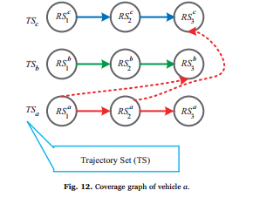

**Figure 3.1 Coverage graph of vehicle a.**

**3.4 ARCHITECTURE**

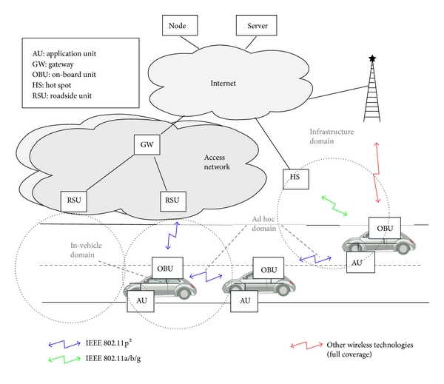 **Figure 3.2 Architecture of Ad-hoc network.**

**Geo-Cast routing protocol**

**Geocast** routing protocol refers to the delivery of information to a group of nodes in a network which are  identified by their geographical locations. It is a specialized form of multicast addressing used by some routing protocols for mobile ad hoc networks. Group members are within a specified geographical region. Whenever a node in the geo-cast region receives a geo-cast packet, it floods the geo-cast packet to all its neighbours.

A geo-cast protocol works if at least one node in the geo-cast region receives the geo-cast packet. Protocols use a jitter technique in order to avoid two packets colliding with each other by a broadcast. Existing geo-cast protocols divided into two categories: data-transmission oriented protocols routing creation, oriented protocols The difference is how they transmit information from a source to one or more nodes in the geo-cast region.

A geographic destination address is expressed in three ways: point, circle (with centre point and radius), and polygon (a list of points, e.g., P(1), P(2), …, P(n–1), P(n), P(1)). A geographic router (Geo Router) calculates its service area (geographic area it serves) as the union of the geographic areas covered by the networks attached to it. This service area is, approximated by a single closed polygon. Geo Routers exchange service area polygons to build routing tables. The routers are, organized in a hierarchy.

**Road-side Units:** The road side units are the detectors which detect the number of vehicles that are passing through them and collects the details of the vehicles including the Vehicle ID, vehicle type and other parameters relating to the vehicles.

**CHAPTER 4**

**IMPLEMENTATION AND ISSUES**

**4.1 ALGORITHM**

* Vid - Vehicle ID
* VDT - Vehicle distance travelled
* IVD - Inter Vehicular Distance
* S - Speed
* N(V)- Number of vehicles in a lane
* P- Packet
* T- Traffic signal
* m- number of vehicles in a network

step 1. Initialization

1.1 Label each vehicle using an unique ID where Vid denotes vehicle ID

1.2 Label each Traffic signal and Detectors(RSU) using an ID

step 2. Dissemination of data

2.1 Transmit packet (Vid,VDT,IVD,S,Destination) to neighbouring vehicles using Geocast routing periodically

step 3. Categorizing data

3.1 Each nearby vehicle receives updates from m vehicles

3.2 Update its local table periodically

Step 4. Check if Vid=="Emergency vehicle"

4.1 Check for alternative shortest route to destination

4.1.1 If no alternative route is present change lane and give route to emergency vehicle

step 5. Detectors receive the packets

5.1 Check if Vid=="Emergency vehicle"

5.1.1 Manage traffic signals with highest priority for emergency vehicles

**4.2 Simulation of Vehicles and Traffic**

SUMO is the Simulation of Urban mobility software that enables to simulate the road traffic. Open Street map  provides the xml based .osm file for any part of the world selected through their website.

$] netconvert --osm-files map.osm -o map.net.xml

This converts the OSM map file into an XML file.

$] polyconvert --osm-files map.osm --net-file map.net.xml --type-file osmPolyconvert.typ.xml -o map.poly.xml

Copy the polyconvert file from SUMO home to our folder. The polyconvert file has the details of the terrains in the map including the buildings, flyovers,railway lines etc.

$] python $SUMO_HOME/tools/randomTrips.py -n map.net.xml -r map.rou.xml -e 100 –l

This assigns cars randomly to the map , the randomTrips.py file generates cars randomly in the simulation map.

The above file is the invoking file to run the SUMO, where the beginning time is 0 and the simulation runs upto 100.

Run the SUMO software by sumo-gui map.sumo.cfg

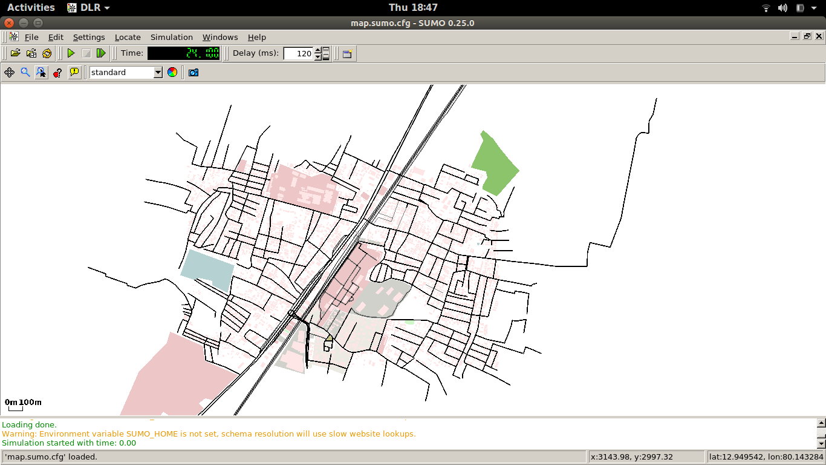

**Figure 4.1 Real world map simulation**

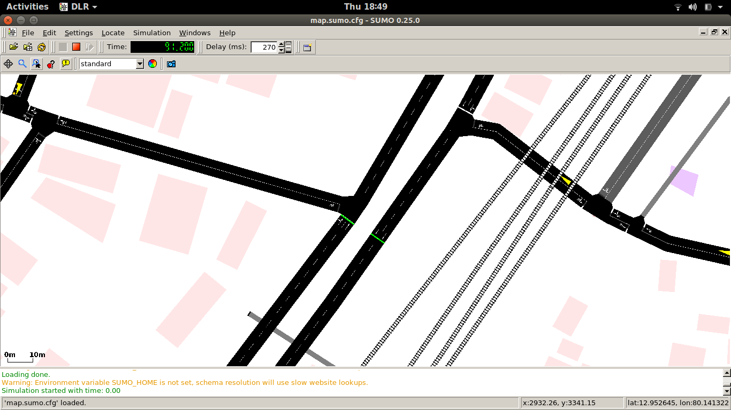

**Figure 4.2 Traffic signals in real world map.**

**4.3 Dissemination of Packets**

Exporting from SUMO to NS2.

$] sumo -c guindy.sumo.cfg --fcd-output guindy.sumo.xml

The sumo.cfg file is converted into an XML file.

$] python /home/srivatsan/sumo-0.26.0/tools/traceExporter.py --fcd-input map.sumo.xml --ns2config-output map.tcl --ns2activity-output activity.tcl --ns2mobility-output mobility.tcl​

This will generate three tcl files (map.tcl, activity.tcl and mobility.tcl).

The map TCL file is the network file where the routing protocol is defined, and here we have used a AODV routing protocol, the mobility.tcl file has the mobility values of all vehicles.

The network simulator is started using this code.

ns map.tcl

nam map.nam

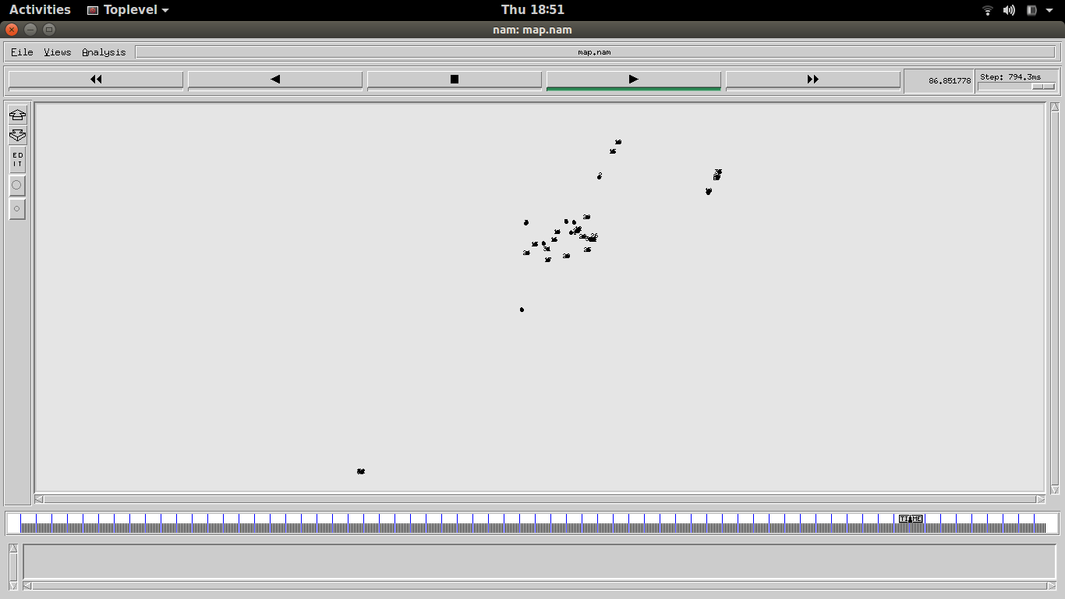

**Figure 4.3 Packet Tracing between vehicles**

Now the map.tr file has all the packet traces information, it has all the packet exchange information between all other nodes which can be further analyzed.

**4.4 Priority to Emergency vehicles**

The following python code has been implemented to detect a vehicle and give priority to the vehicle by changing the traffic signal. There are three routes North to South and East to West and West to East.

1. Set the Traffic light of EW to green
2. Check the NS path for any vehicle.
3. If the detected vehicle’s type is Emergency vehicle then Change the traffic light to green.
4. Check for flooding of Vehicles in one street and manage Traffic signals according to it.

# we start with phase 2 where EW has green

traci.trafficlights.setPhase("0", 2)

while traci.simulation.getMinExpectedNumber() is greater than 0 then

traci.simulationStep(), start the simulation

if traci.trafficlights.getPhase("0") is equal to 2

# we are not already switching

if traci.inductionloop.getLastStepVehicleNumber("0") is greater than 0:

# there is a vehicle from the north, switch

traci.trafficlights.setPhase("0", 3)

else:

# otherwise try to keep green for EW

traci.trafficlights.setPhase("0", 2)

step += 1

traci.close()

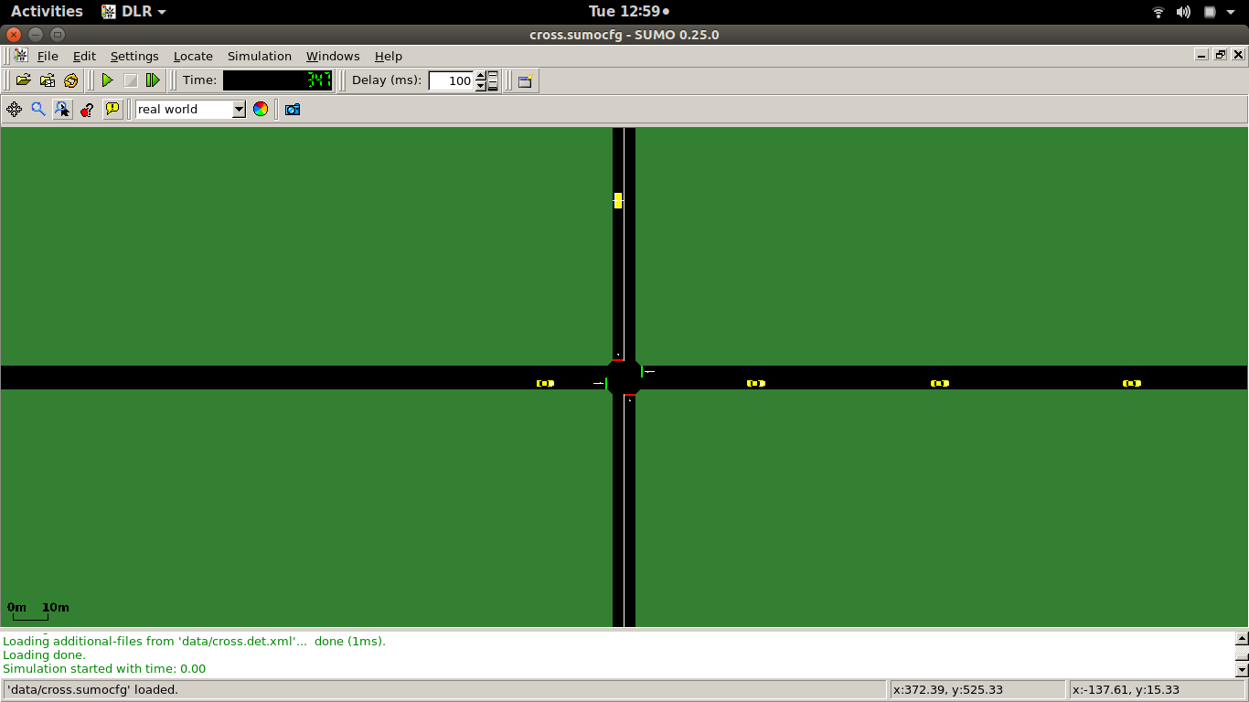

**Figure 4.4 Simulation of the Traffic signals**

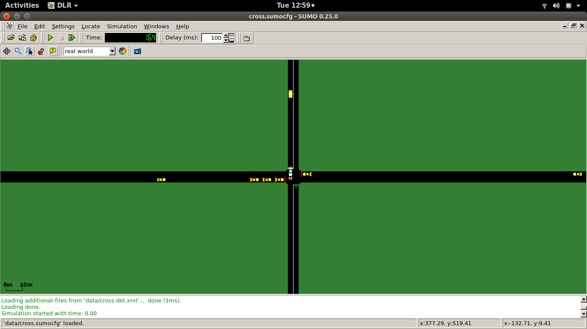

**Figure 4.5 Priority for Emergency vehicles.**

**CHAPTER 5**

**RESULT AND DISCUSSION**

In this phase the simulation of vehicles in a real world map is done by using the Simulation of Urban mobility software (SUMO) by embedding a real world map from the openstreet map and the communication between the vehicles in the network has been achieved by using Network Simulator 2 (NS2). The number of vehicles in the network can be given as input and they are given random routes in the real world map. Priority is given to emergency services by TRACI programming.

**CHAPTER 6**

**CONCLUSION AND FUTURE WORK**

**6.1 CONCLUSION**

Thus in this phase the implementation of creating a network in a real world map is done and the traffic is simulated in the real world map using the SUMO software and VANET is simulated using NS2.

**6.2 FUTURE WORK**

The identification of nearby vehicles and notifying other vehicles in the network about its presence and rerouting vehicles to give route to the emergency vehicle and also to notify traffic signals and change them in a full network accordingly so as to avoid traffic and give way to emergency vehicles.

**REFERENCES**

[1]Yixiao Huang a , Lei Zhao a , Tom Van Woensel b , Jean-Philippe Gross

“Time-dependent vehicle routing problem with path flexibility “ ,Transportation journal part B 95 (2017) Elsevier journal.

[2] Jubair Mohammed Bilal, Don Jacob, “Intelligent traffic control system,”, 2007 IEEE International Conference on Signal Processing and Communications (ICSPC 2007).

[3] Raik Aissaoui, Hamid Menouar, Amine Dhraief, Fethi Filali, Abdelfettah Belghith, Adnan Abu-Dayya , “Advanced Real-Time Traffic Monitoring System based on V2X Communications “ , IEEE ICC 2014 - Mobile and Wireless Networking Symposium.

[4] [Adwitiya Mukhopadhyay](http://ieeexplore.ieee.org/search/searchresult.jsp?searchWithin=%22Authors%22:.QT.Adwitiya%20Mukhopadhyay.QT.&newsearch=true), [S Raghunath](http://ieeexplore.ieee.org/search/searchresult.jsp?searchWithin=%22Authors%22:.QT.S%20Raghunath.QT.&newsearch=true), [M Kruti](http://ieeexplore.ieee.org/search/searchresult.jsp?searchWithin=%22Authors%22:.QT.M%20Kruti.QT.&newsearch=true), “Feasibility and performance evaluation of VANET techniques to enhance real-time emergency healthcare services”, IEEE conference , ICACCI 2016.

[5] [Peppino Fazio](http://ieeexplore.ieee.org/search/searchresult.jsp?searchWithin=%22Authors%22:.QT.Peppino%20Fazio.QT.&newsearch=true), [Floriano De Rango](http://ieeexplore.ieee.org/search/searchresult.jsp?searchWithin=%22Authors%22:.QT.Floriano%20De%20Rango.QT.&newsearch=true), [Andrea Lupia](http://ieeexplore.ieee.org/search/searchresult.jsp?searchWithin=%22Authors%22:.QT.Andrea%20Lupia.QT.&newsearch=true), “A new Application for enhancing VANET services for Emergency Situations using the WAVE/802.11p standard”, IEEE conference Wireless days (WD),2013 IFIP.

[6] A.I. Diveeva, E.A. Sofronovab, V.A. Mikhalevb, A.A. Belyakovb “Intelligent traffic flows control software for megapolis”, XIIth International Symposium «Intelligent Systems», INTELS’16, 5-7 October 2016, Moscow,Russia.